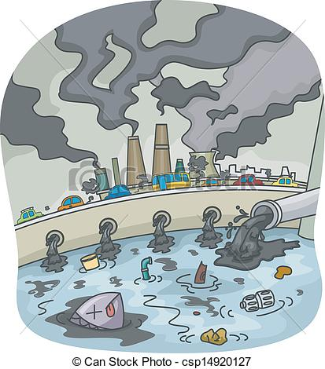
Who Polluted the River

1a. Imagine that the container of water in front of you was taken from the river a long, long time ago. Describe how it looks to you.

1b. Would you drink this water?
1c. Eat fish that came from it?
1d. Swim in it?

2a. When new people started to move in at that time, how do you think they used the river?

2b. Do we use the river the same way today?

3a. How does farming cause pollution of the water?

3b. Is this water safe to drink?
3c. Would you swim in it?
3d. Is it safe for animals to drink and fish to swim in?

4a. How do people living in suburbs cause pollution of the water?

4b. Would you drink this water now?
4c. Would you swim in it?
4d. Go boating on it?
4e. Is it safe for fish and animals?

5. How do cities create pollution?

6. To what extent do you contribute to this pollution?

7. Can you think of ways that we can prevent pollution or clean up the river?
Building
Parks
Suburbs
Cities

